SQL Assignments - Set 3

The below 10 questions are based on the Emp table:

- Display the average, lowest, highest and difference in lowest and highest salaries for each department number.

- Display the number of employees within each job.

- Display the lowest salaries job-wise within each department number.

- Display only those jobs where the minimum salary is greater than or equal to 3000.

- Display the records sorted as per the job. Make sure that within each job the records are sorted as per the highest to lowest salaries.

- Display Deptno, total of that deptno and Grade. Grade should be A if the total is greater than 10000, else it should be B. Sort the summary output as per the highest to lowest Grade.

- Calculate and display only the average salaries paid to all those employees where the employee name starts with A and name starts with S.

- Product exactly same output as shown below:

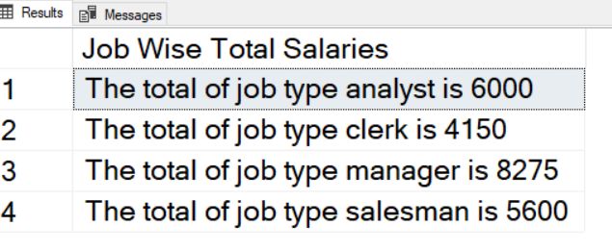

- Display Mgr code and number of sub ordinates reporting to them for only those managers who have at least 3 sub ordinates.

- Product exactly same output as shown below:

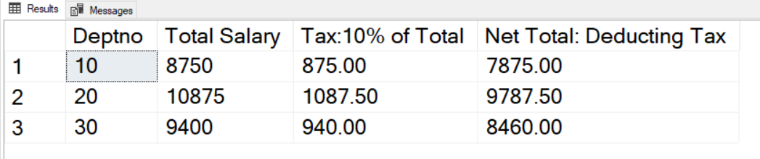

The below 10 questions are based on the Products2 table:

- Display the Highest sales for each product within a country for each continent.

- Display the average sales for each product region-type wise within each area for each country.

- Display the country-wise number of products for each product

- Display the Country wise total of sales for each Continent. The summary records should be shown as per highest to lowest sequence of totals. But in the final display only first 2 records should be shown.

- Display the exact following report:

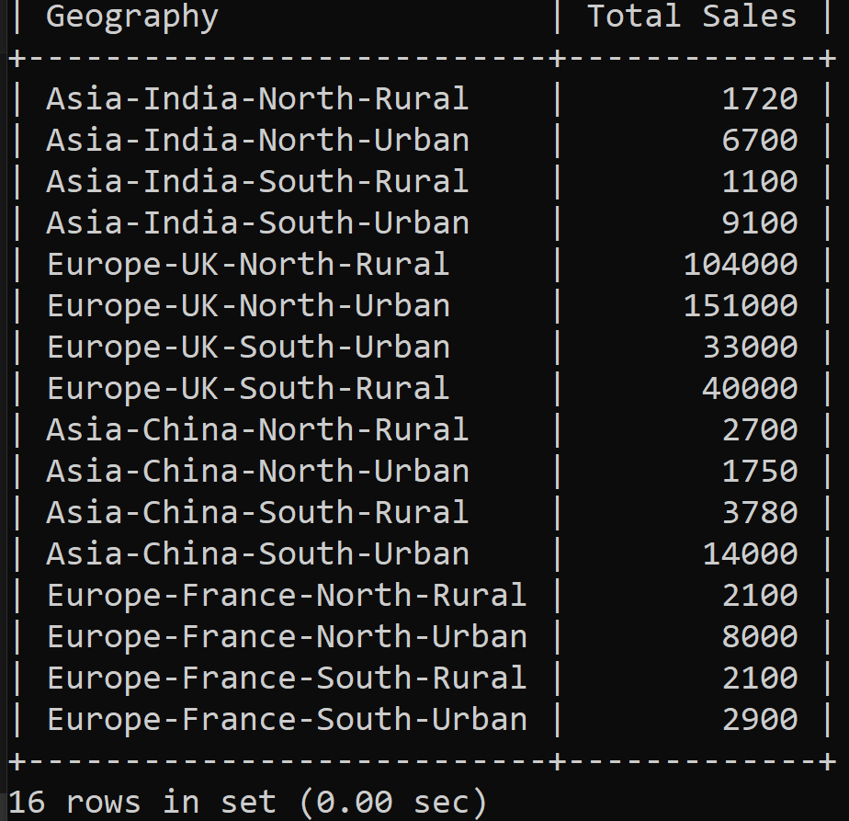

- Display the product name wise total sales excluding records of Rural region of North area.

- Display country wise average sales excluding country India

- Display product name wise total sales for all the transactions done from transaction id 23 onwards.

- Display Country wise count of transactions done.

- Display Country wise average sales done of Samsung only.

The below 2 questions are based on the India table:

- Display product name wise count of records from India table.

- Display product name wise total of quantity for the transactions having quantity above 1.

The below 3 questions are based on the Code_Data table:

- Display the total amount as per code which will be grouped by 3rd, 4th, 5th and 6th characters of code column’s values.

- The last 4 digits of code values represent the year. Display year wise total amount.

- Display the average amount as per the 6th character of code column’s values.

